

Preliminary Examinations II 2010

Pre-university 3

H2 CHEMISTRY 9647 / 01

Thursday 23 Sep 2010 1h

Additional materials:
OMR
Data Booklet

READ THESE INSTRUCTIONS FIRST

1. Do not turn over this question paper until you are told to do so.

2. Write your name, class and index number in the spaces provided at the top of this page and on any separate answer paper used.

3. Attempt ALL the questions in Section A and B.

4. All answers are to be shaded on the OMR form provided using a 2B pencil.

6. Hand in your answers to the paper (OMR form) and question paper separately.

INFORMATION FOR CANDIDATES

No extra time will be given for shading of OMR form.

SECTION A (30 MARKS)
Answer all questions on the OMR form provided

For each question, there are four possible answers, A, B, C and D. Choose the one you consider correct.

- Which compound contains the highest percentage of nitrogen by mass?

A NH₂OH (M_{r} = 33.0) B NH₄NO₂ (M_{r} = 64.0)
C N₂O₃ (M_{r} = 76.0) D NH₄NH₂CO₂ (M_{r} = 78.0)

- 0.250 g of an element, M, reacts with excess fluorine to produce 0.547 g of the hexafluoride, MF₆. What is the element?

A Cr B Mo C S D Te

- Equal masses of each of the following compounds were treated with excess hydrochloric acid. Which produced the greatest volume of carbon dioxide gas?

A sodium carbonate B magnesium carbonate
C potassium carbonate D calcium carbonate

- 30 cm³ of propane is mixed with 200 cm³ of oxygen and the mixture is ignited.
What is the volume of the resulting gas mixture? (All volumes are measured at room temperature and pressure.)

A 90 cm³ B 120 cm³
C 140 cm³ D 210 cm³

- A gaseous mixture containing ethane and methane underwent complete combustion to produce 5.28 g of carbon dioxide and 3.78 g of water. What is the volume ratio of ethane to methane in the original mixture?

A 1:1 B 1:2 C 2:1 D 1:4

- Kravatz the Klown wishes to fill a 5.8 dm³ balloon with nitrogen gas. Searching for cheap and effective methods to quickly produce the nitrogen gas necessary, he discovered that azide (N₃–) salts, although highly toxic, are often used to produce nitrogen gas. Sodium azide, commonly used in car airbags, decomposes to sodium and nitrogen gas.

What mass of sodium azide would Kravatz need to produce 5.80 L of nitrogen gas when measured at 25°C and 103 kPa?

A 5.22 g B 10.1 g C 10.4 g D 15.2 g

- Using the data given below, which of the following pairs of oxides would be most stable?

Element | W | X | Y | Z
Atomic Number | n | n + 1 | n + 2 | n + 3
Second ionization energy / kJ mol^{–1} | 2297 | 2666 | 3051 | 1145

A WO, X₂O₃ B W₂O, Y₂O₃
C XO₃, Z₂O D Y₂O, ZO

- A 1 dm³ vessel containing argon gas at a pressure of 100 kPa is attached via a tube and tap of negligible volume to a 2 dm³ vessel containing neon gas at a pressure of 150 kPa.
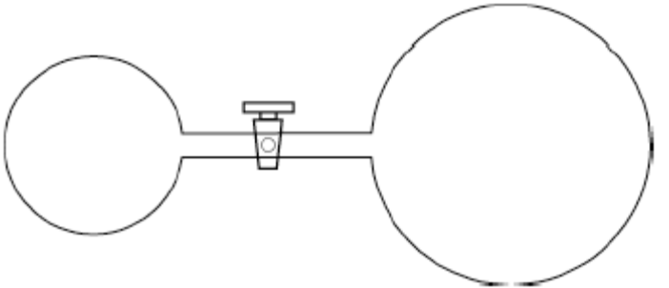

When the tap is opened and the gases allowed to mix, what is the final pressure in the vessels?

A 125 kPa B 133 kPa
C 150 kPa D 250 kPa
- The geometry of the atoms in the species PCl₄⁺ is best described as

A tetrahedral B distorted tetrahedron
C square planar D trigonal bipyramidal

- Which of the following cannot be determined by a single experiment?

A Enthalpy change of formation of ethyne
B Enthalpy change of combustion of methanol
C Enthalpy change of solution of sodium hydroxide
D Enthalpy change of neutralisation of hydrochloric acid by sodium hydroxide.

- When a catalyst is used, the activation energy of the forward reaction is reduced to 35 kJ mol^{–1}.
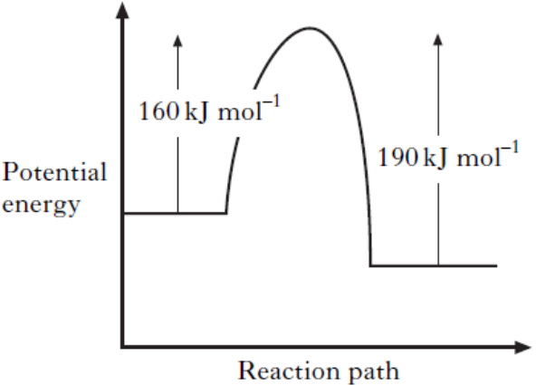

What is the activation energy of the catalysed reverse reaction?

A 30 kJ mol^{–1} B 35 kJ mol^{–1}
C 65 kJ mol^{–1} D 190 kJ mol^{–1}

- When 1.00 g of ethanol was burnt under a container of water, it was found that 100 cm³ of water was heated from 15°C to 65 °C. The process was known to be only 70% efficient.

What is the enthalpy change of combustion of ethanol?

A –961 kJ mol^{–1} B –1390 kJ mol^{–1}
C –1370 kJ mol^{–1} D –8870 kJ mol^{–1}
- A small amount of solid lead iodide was added to a beaker of water, which was stirred. Most of the solid settled on the bottom of the beaker, but a little dissolved, establishing the equilibrium

PbI₂(s) Pb²⁺(aq) + 2I–(aq).

The rates of the forward and reverse reactions were monitored over time, producing the graph shown below:

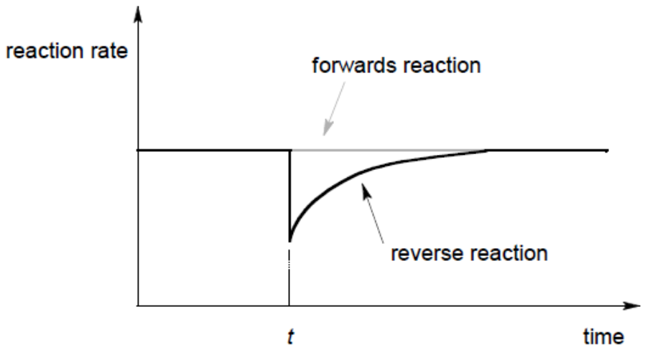

What happened at time t?

A The beaker was cooled in an ice-bath.
B A small volume of Pb(NO₃)₂(aq) was added to the beaker.
C A small amount of solid PbI₂ was removed from the beaker.
D A small amount of water was added to the beaker.

- The equilibrium constant for the reaction

N₂O₄(g) 2NO₂(g)

is 6.10 x 10^{–3} at 25°C.

Calculate the value of K for this reaction: NO₂(g) ½N₂O₄(g)

A 327 B 164 C 12.8 D 3.05 x 10^{–3}

- Equal volumes of solutions of ethanoic acid and hydrochloric acid, of equal concentration, are compared.

In which of the following cases does the ethanoic acid give the higher value?

A pH of solution
B Conductivity of solution
C Rate of reaction with magnesium
D Volume of sodium hydroxide solution neutralized

- The position of equilibrium lies to the right in each of these reactions.

N₂H₅⁺ + NH₃NH₄⁺ + N₂H₄
NH₃ + HBrNH₄⁺ + Br–
N₂H₄ + HBrN₂H₅⁺ + Br–

Based on this information, what is the order of acid strength?

A HBr > N₂H₅⁺ > NH₄⁺ B N₂H₅⁺ > N₂H₄ > NH₄⁺
C NH₃ > N₂H₄ > Br– D N₂H₅⁺ > HBr > NH₄⁺

- What mass of copper is deposited when a current of 10.0A is passed through a solution of copper(II) nitrate for 30.6 seconds?

A 0.101g B 0.201g C 0.403g D 6.04g

- As the atomic number of the Group I metals increases

A the density decreases
B the atomic size decreases
C the melting point increases.
D the first ionisation energy decreases

- Which of the following chlorides is likely to have least ionic character?

A BeCl₂ B CaCl₂ C LiCl D CsCl

- In which series are the species listed in order of increasing size?

A N, O, F B Na, Mg, K
C Cr, Cr²⁺, Cr³⁺ D Cl, Cl–, S^{2–}

- How many different aldehydes have the formula C₅H₁₀O?

A 2 B 3 C 4 D 5

- What are the hybridisations of the carbon atoms labeled C₁ and C₂, respectively,
in glycine?
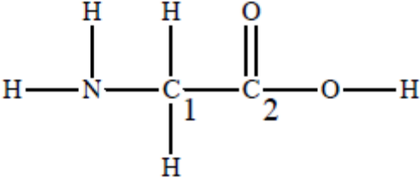
C₁ C₂
A sp² sp²
B sp² sp³
C sp³ sp²
D sp³ sp³

- Which one of the following can exhibit both geometrical and optical isomerism?

A (CH₃)₂C=CHCH(CH₃)CH₂CH₃
B CH₃CH₂CH=CHCH(CH₃)CH₂CH₃
C (CH₃)₂C=C(CH₂CH₃)₂
D CH₃CH₂CH(CH₃)CH(CH₃)C=CH₂

- Which of the following does not apply to the reaction between methane and chlorine?

It involves

A homolytic fission B a chain reaction
C a carbocation intermediate D free radicals.

- When 2-bromobutane is reacted with potassium cyanide and the compound formed is hydrolysed with dilute acid, the final product is

A butanoic acid B pentanoic acid
C 2-methylbutanoic acid D 2-methylpropanoic acid.

- A substance, X, is readily oxidised by acidified potassium dichromate solution to give a product which does not react with sodium carbonate, nor with Tollens’ reagent.

Which of the following could represent the structure of X?

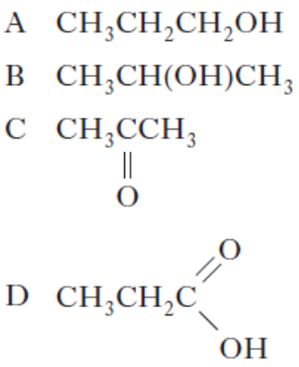 B

- Which one of the statements about the following ester is correct?

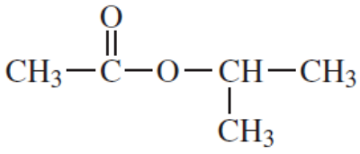

A It is a chain isomer of pentanoic acid.
B It is a functional group isomer of ethyl propanoate.
C It can be hydrolysed to produce an alcohol that can also be formed by the acid-catalysed hydration of propene.
D It can be hydrolysed to produce an alcohol that is resistant to oxidation by acidified potassium dichromate(VI).

- A sequence of reactions is shown below.

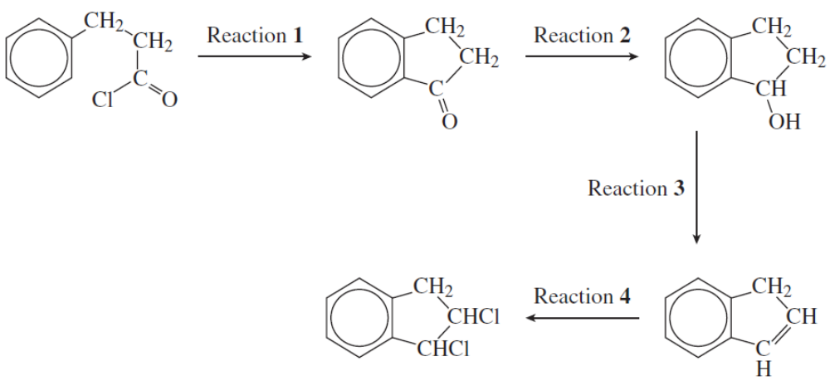

A correct list of substances for the sequence is

Reaction 1 Reaction 2 Reaction 3 Reaction 4
A CH₃COCl NaBH₄ conc H₂SO₄ Cl₂
B AlCl₃ HCl NaOH Cl₂
C AlCl₃ NaBH₄ conc H₂SO₄ HCl
D AlCl₃ NaBH₄ conc H₂SO₄ Cl₂

- Which of the following shows the above compounds in order of increasing acid strength?
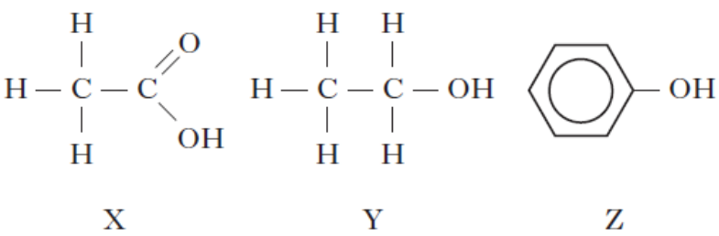

A X Y Z B Y Z X
C Z X Y D X Z Y

- Peptides are composed of amino acids joined by amide bonds. Which of the following statements is not correct?

A There is free rotation about the C-N bonds.
B Amide groups participate in hydrogen bonding interactions.
C Peptides have trigonal planar shape with respect to the N atom.
D Amide bonds are more resistant to hydrolysis than are similar ester groups.

SECTION B (10 MARKS)

For each of the questions in this section, one or more of the three numbered statements 1 to 3 may be correct. Decide whether each of the statements is or is not correct. The responses A to D should be selected on the basis of

A | B | C | D
1, 2 and 3  are correct | 1 and 2  only are correct | 2 and 3  only are correct | 1 only  is correct

No other combination of statements is to be used as a correct response

- Species with at least one bond angle of 90° include

1 XeF₄ 2 PF₅ 3 [Co(NH₃)₆]³⁺

- Which change(s) is/are accompanied by an increase in entropy of the system?

- sublimation of iodine
- freezing of water
- conversion of O₂(g) to O₃(g)

- Which of the following statement(s) is/are true?

1 When SiCl₄ is added to water, a precipitate is formed.
2 sulfur has a higher melting point than phosphorus because the intermolecular attractions are stronger.
3 When AlCl₃ is dissolved in water, [Al(H₂O)₅(OH)]²⁺(aq) is one of the ions formed.
- Which of the following statement(s) is/are correct?

1 The shape of the BrF₄– ion is square planar.
2 When aqueous silver nitrate and an excess of aqueous ammonia are added to aqueous sodium iodide, a yellow precipitate is formed.
3 The boiling point of bromine is lower than that of iodine because the Br–Br bond is weaker than the I–I bond.

- Ionone, shown below, is a compound responsible for the smell of raspberries.

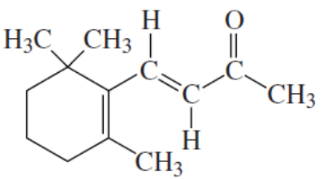

Mechanisms involved in reactions of ionone include

1 electrophilic addition.
2 nucleophilic addition.
3 nucleophilic substitution.

- The artificial sweetener aspartame has the structure
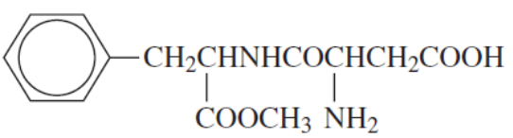

Which of the following statement(s) is/are true?

1 it can form a zwitterion.
2 it contains an amide link.
3 it has three chiral carbon atoms.

- Optical isomerism can be exhibited by
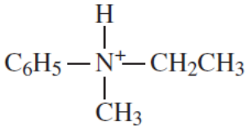

1

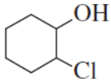
2

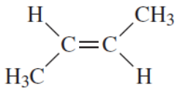
3

- 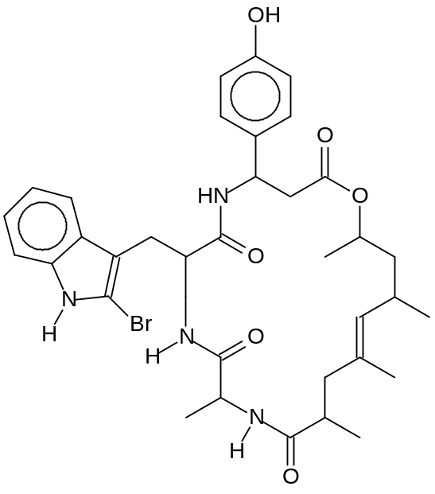Jasplakinolide is a cyclic depsipeptide isolated exclusively from marine sponges. It disrupts the formation of the actin microtubules that make up the skeleton of cellular organelles, often resulting in automatic cell death. Hence it has found itself an invaluable tool in research related to anti-cancer agents.

Which reaction(s) will Jasplakinolide undergo?

- On heating with NaOH(aq), five moles of NaOH are used up per mole of Jasplakinolide.
- On heating with reflux with acidified concentrated KMnO₄, 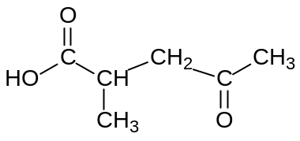

is a product.

- Addition of bromine in an organic solvent causes six atoms of bromine to be incorporated into the molecule.

- A mechanism for the reaction between ammonia and ethanoyl chloride is given below.

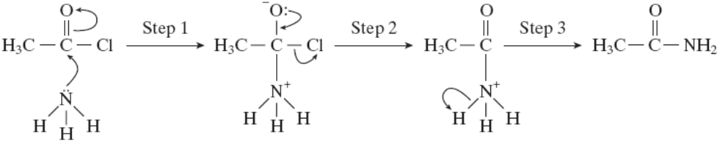

Which of the following statement(s) is/are correct?

1 The ammonia behaves as a nucleophile.
2 The proton loss in step 3 has been shown incorrectly.
3 The ammonia attacks an electron-deficient carbon atom.

- An aromatic hydrocarbon X was made to react with an excess of hot aqueous alkaline potassium manganate(VII) and the product was treated with an excess of aqueous acid to give 1,4-benzenedicarboxylic acid.

Possible structure(s) of X is/are

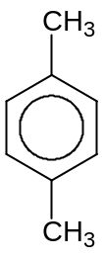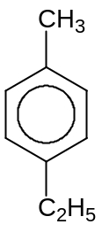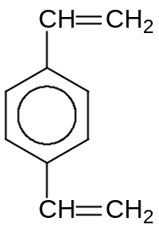

1 2 3

~ All the Best! ~

